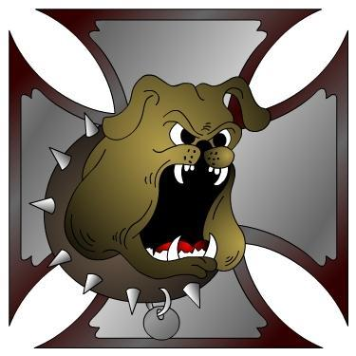
DOGGs
Is a group of Dallas Oregon Old Guys and Gals that are interested in wholesome motorcycle fun. Don't let our name fool you, we are made up of a variety of ages and bikes.
https://www.facebook.com/groups/doggs.members/
http://www.doggs.us
Jan 7; Meeting. Discuss about donating to the school ‘backpack’ lunch program.
I need input for ideas on rides and events for this year. I plan to have tentative ride/event dates in the Feb newsletter.
Jan 21; Dinner Social. Where???
Feb 4: Meeting.
Ride Safe and have fun!! EEEEHAAAA!!!!
